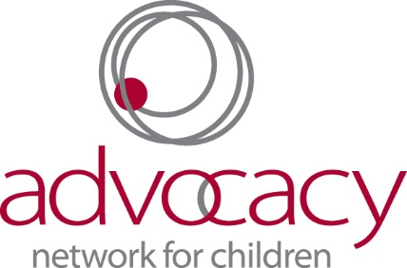

Run for CASA’s Kids
Waiver and Release of Liability for Participants

Participant Information
Name: __________________________________________________
Phone: __________________________________________________
Email: ___________________________________________________
Date of Birth (if under 18): ___________________________________

Emergency Contact
Name: __________________________________________ Phone: __________________________
Relation: ________________________________________

In consideration of being permitted to participate in the Run for CASA’s Kids, I agree to assume all risks inherent in participation in such program, whether they are apparent to me or not. I certify that I am in good physical health and fit to participate. Nevertheless, I acknowledge that participation carries an inherent risk of injury to my person and damage to my property. I hereby waive and release, for myself and for my heirs and assigns, any and all claims, causes of action, or liabilities which may hereafter accrue against Advocacy Network for Children, and its affiliates, agents, employees, volunteers, officers, directors, successors and assigns, Advocacy Network for Children, and any and all sponsors, their representatives and successors, that may arise as a result of my participation in this event, including any and all claims for personal injuries caused by Advocacy Network for Children’s negligence.

Further, I hereby grant full permission to any and all of the foregoing to use any photographs, motion pictures, recordings, or any other record of these events for any legitimate purpose, including commercial advertising, without monetary payment to me. (This information is protected by the Privacy Act).

Signature of Participant: _____________________________________________________________
Date: _______________________

This section to be read and signed by parent/legal guardian if Participant is a minor:

As the parent/legal guardian of the above-named Participant, I hereby waive and release on behalf of my child, any and all claims, and causes of action, or liabilities which may hereafter accrue against Advocacy Network for Children and its affiliates, agents, employees, volunteers, officers, directors, successors and assigns, Advocacy Network for Children, and any and all sponsors, their representatives and successors, by reason of my child’s participation in said program, including any and all claims for personal injuries caused by Advocacy Network for Children’s negligence. In addition, I accept full responsibility for the care and supervision of my child during the above-described event.

Signature of Parent/Legal Guardian: ______________________________________________________ Date: ________________________

